Functions with 2D Data

Look at this code:
def show_names(records):
for record in records:
print(record[0])
def find_members(records, target):
for record in records:
if record[0] == target:
return record[1]
return -1
clubs = [["art", 12], ["chess", 18], ["code", 15]]
show_names(clubs)
name = input("Club to find: ").lower()
members = find_members(clubs, name)
print("Search result:", members)

What do you think this code will display?
Click or tap here to enter text.

Run the code. Compare the result with your prediction:
Click or tap here to enter text.

Let’s investigate! Answer the questions below:
- What value is passed into records when show_names(clubs) runs?
Click or tap here to enter text.

- Why must return -1 come after every row has been checked?
Click or tap here to enter text.

- What happens if the target is not normalised in the same way as stored record names?
Click or tap here to enter text.

- How does returning a field value differ from printing it inside the function?
Click or tap here to enter text.

Functions with 2D Data

Look at this code:
def show_names(records):
for record in records:
print(record[0])
def find_members(records, target):
for record in records:
if record[0] == target:
return record[1]
return -1
clubs = [["art", 12], ["chess", 18], ["code", 15]]
show_names(clubs)
name = input("Club to find: ").lower()
members = find_members(clubs, name)
print("Search result:", members)

Use the code above to help you. After completing each challenge below, run your program to test that it works correctly. Save each completed challenge program in a new file.

Programming Challenges

Challenge 1
Change the search target to code. The final labelled result must be 15 while all three club names still display first.
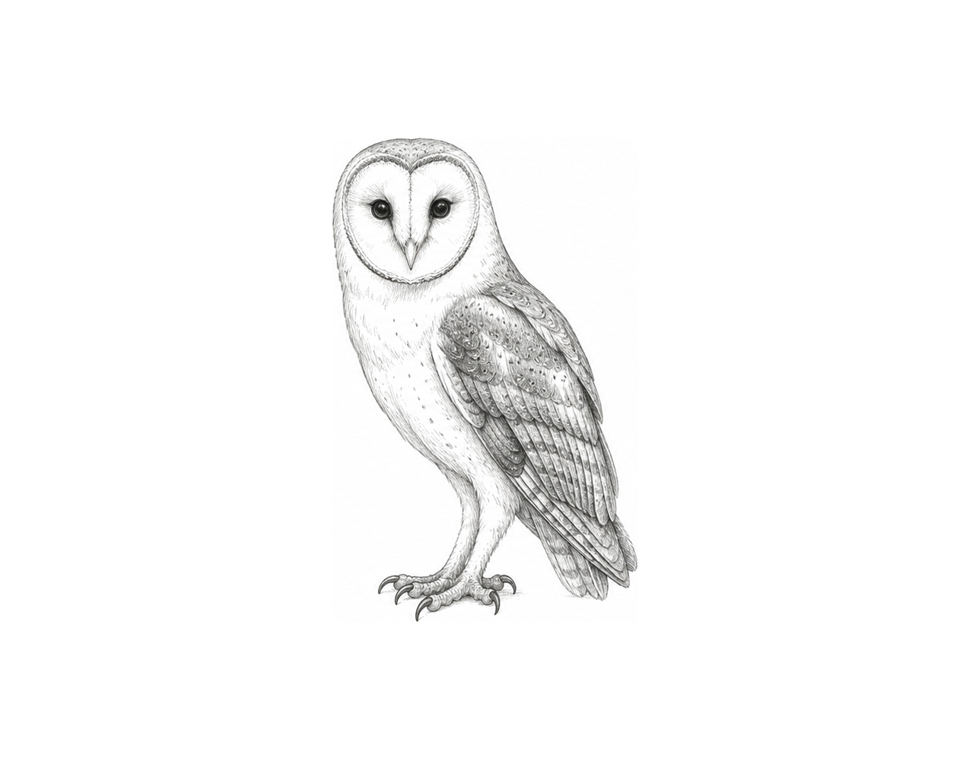

Challenge 2
Add a function total_members(records) that loops through the rows, maintains a running total, and returns it. Display the labelled total; the supplied data must produce 45.

Challenge 3
Build a small results manager using [name, score] rows and three functions: display every record, search by lower-case name, and return the highest score. The main program must call all three and show a clear not-found message for a missing name.

Functions with 2D Data

Fix the code!

This code has errors! Look closely at the code to find the problems:

def find_members(records, target):
for record in records:
if record == target:
return record[1]
return -1
clubs = [["art", 12], ["chess", 18]]
print(find_members("chess"))

Rewrite the whole program in the box below with fixes to the errors.
Click or tap here to enter text.

After you are confident that you fixed all the errors, copy the code from the box and run it.

Did it work correctly on your first try? Did you find all the errors?
Click or tap here to enter text.

